Stone Circle Pavers
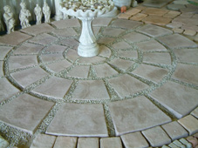
Length
Width A
Width B
Description | Length | Width A | Width B | Price
Centre | 280mm | 400mm |  | R43.00
Small | 290mm | 260mm | 180mm | R43.00
Medium | 365mm | 380mm | 280mm | R63.00
Large | 435mm | 520mm | 400mm | R79.00

Diameter of small circle (centre, small and medium): 2.5 meter
Diameter of large circle (centre, small, medium and large): 3.5 meter

Cardiff circle
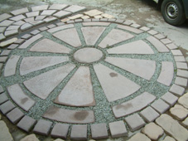
170 x 170
R9.00
Length 800 x 520 x 140
R79.00
Length 65 x width 120
R63.00
Dia 480
R63.00

Pavers can also be purchased individually.
Prices excludes VAT @ 15% and delivery

